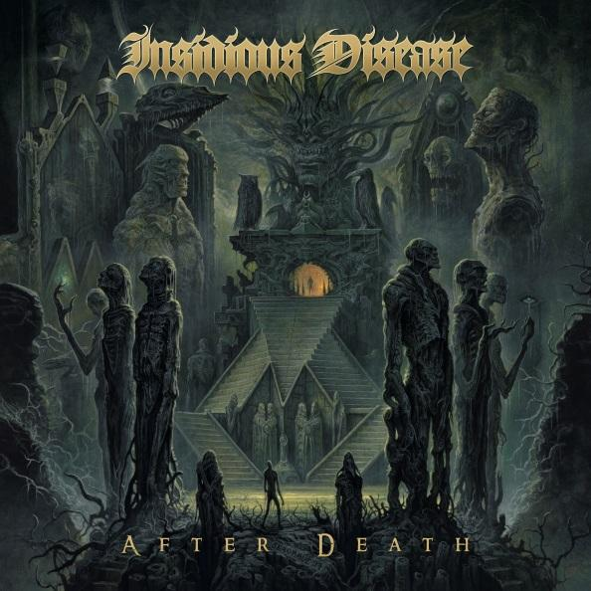

**INSIDIOUS DISEASE**

»***After Death***«

*OUT: 30/10/2020*

|  |  |
| --- | --- |
| **Line-up:** | **INSIDIOUS DISEASE online:** |
| Marc Grewe| vocals  Silenoz | guitars  Cyrus| guitars  Shane Embury| bass  Tony Laureano| drums | [www.facebook.com/InsidiousDisease](http://www.facebook.com/pg/InsidiousDisease)  [www.twitter.com/insidiousnews](http://www.twitter.com/insidiousnews)  www.nuclearblast.de/insidiousdisease |

Sonically inducing a depraved and morbid condition of the mind, **INSIDIOUS DISEASE** have returned to present their second full length album: **»After Death«.** Freshly signed to **Nuclear Blast Records,** the band convenes (with members currently and previously of **DIMMU BORGIR, MORGOTH, NILE, NAPALM DEATH,** and **SUSPERIA**) to create a modern venture into classic death metal. Still in the early stages of existence with only their debut album »**Shadowcast«**(2010) preceding, **INSIDIOUS DISEASE** are ripe with a hellish energy that seeks to sear its way across the universe of heavy metal. “*It’s not supposed to be re-inventing the wheel or anything, it’s just about finding a good groove that we feel comfortable with*,” explains guitarist and founding member **Silenoz**.

The album artwork created by master painter **Dan Seagrave** is a gray/green spectrum of detailed, otherworldly misery that could take hours to fully observe. A chasm full of soulless creatures emerge in a dismal nothingness, only to freeze in the spectrum of time and enter a state of permanent rot. An exquisite amount of detail is contained in this post-terminal landscape of physical degradation; some of the figures stand against a pathway leading to a stone sanctuary and appear to present the glow of magic from their fingertips. With faces, figures, and hidden spaces aplenty, it takes a visual and meditative state to truly absorb and interpret every detail.

The title **»After Death«** carries with it philosophical concepts that can be found weaved throughout the lyrical content of the entire album; conspiracy theories, perception of reality and existence, the dread of disease, and the inescapable nature of death are just some of the ideas touched upon. These intriguing bits of subject matter are intelligent fuel for the band and their writing: *“if someone who reads this lyrical content begins to think or wonder about these things, for me that is another bonus,*” describes **Silenoz**. Although topics of morbidity are fairly common in the realm of death metal, the members of **INSIDIOUS DISEASE** take a deeper step into their interpretations of these concepts through their violent, electrically-charged melodies.

Songs like **‘Soul Excavation’** *(also released on Nuclear Blast’s 2019* ***Death… Is Just The Beginning*** *compilation)*, are highly representative of the album as a whole. Authoritative and straightforward riffs vibrate heavily with destructive, compound vocals. The technicality of the drumming and the precision of the guitar flow seamlessly with one another creating a massive, catchy groove. The lyrics characterize the struggles of PTSD, and the hardships of returning home from war a different person.

‘**Invisible War’** drops in with a sheer sonic countdown to the explosions of battle. A consistent, rough, and weighty beat leads way to breaths of fresh guitar and blended vocals. Obvious themes of combat and the questionable nature of the origins of war are inserted between thundering, fluid compositions. The album concludes monstrously with a track entitled **‘Secret Sorcery’**, again demonstrating the band’s ability to breathe life into complex and metaphysical concepts. Starting out with a slower tempo, a very great amount of tension builds in the short time before the eruption of speedy guitar work and frighteningly powerful vocals.

The writing process for **»After Death«** started almost immediately after the first album cycle. Song development is a group effort involving input from each of its experienced musicians. The lyrics were written in a very old-school rhyming pattern that will adhere well with fans of classic, discernable, death metal. Recorded by the band themselves in **Silenoz’** home studio, they then employed **Russ Russell** (**DIMMU BORGIR**, **NAPALM DEATH**, **AT THE GATES**) for the mixing and mastering. While crisp, clean, and well produced, the album maintains a gritty element of robust and dominating sound.

**»After Death«** is a modern death metal powerhouse that will awaken your old school instincts to forage for more. Death Metal hasn’t died, it just required a compelling, and qualified reignition.